Supplementary Fig. 1. PRISMA Flow Diagram.

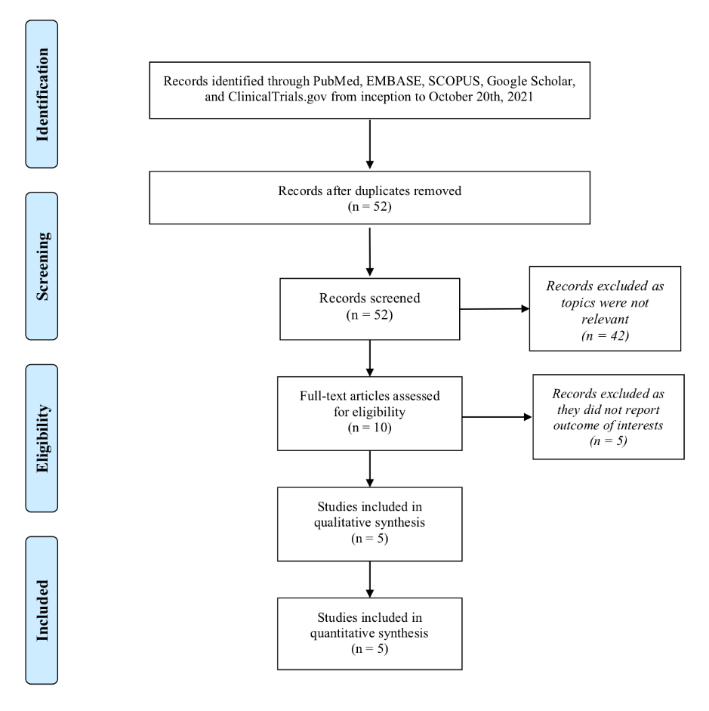

Supplementary Table 1. The Cochrane Collaboration tool for assessing risk of bias of the included randomized controlled trial.

First author, year | Selection bias |  | Performance bias | Detection bias | Attribution bias | Reporting bias | Other bias | Overall bias risk
 | Random sequence generation | Allocation concealment
Ghannam et al., 2018 | Low | Low | Low | Low | Low | Low | Low | Low
Rolantova et al., 2018 | Low | Low | Low | Low | Low | Low | Low | Low

Cochrane Collaboration tool for assessing risk of bias is used to evaluate the quality of each randomized controlled trial by assigning a score (high, low, or unclear) for each individual element from six domains (selection, performance, detection, attrition, reporting, and other)

Supplementary Table 2. Appraisal of clinical trials for bias using Newcastle-Ottawa scale.

First author, year | Selection |  |  |  | Comparability | Outcome |  |  | Total score
First author, year | Representativeness | Selection of the non-exposed cohort | Ascertainment | Endpoint does not present at start | Comparability | Assessment of outcome | Follow-up duration | Adequacy follow-up | Total score
Conte, 2014 | * | * | * | * | ** | * | * | * | 9
Gurses, 2015 | * | * | * | * | ** | * | * | * | 9
Yasar, 2019 | * | * | * | * | ** | * | * | * | 9
Studies’ quality was rated as good, fair, and poor by awarding stars in each domain. A “good” quality score required 3 or 4 stars in the selection, 1 or 2 stars in comparability, and 2 or 3 stars in outcomes. A “fair” quality score required two stars in the selection, 1 or 2 stars in comparability, and 2 or 3 stars in outcomes. A “poor” quality score reflected 0 or 1 star(s) in selection, or 0 stars in comparability, or 0 or 1 star(s) in outcomes.

